**Alpha Group Ltd is a Pan Nigeria company that focuses on retail sales of different electronic products. They currently operate in 17 locations across Nigeria but there is a need to prioritize their investments across different products especially for the main office (Lagos).**

**PLURAL CODE POWERBI PROJECT**

**You are the Data Analyst working with Alpha Groups Ltd, your boss who is the Regional Sales Manager for Lagos has given you the mandate to carry out analysis on the company’s historical sales data in order to help him in making further decisions in terms of improvement and Investment.**

Just like it has been stated above, I was given the following task to help my boss, here are some of my

**Findings and Insight;**

First of all, Lagos state is already doing well as a region, their sales are commendable, but I would like to explain my visualization to walk you through my insights before I go into recommendations.

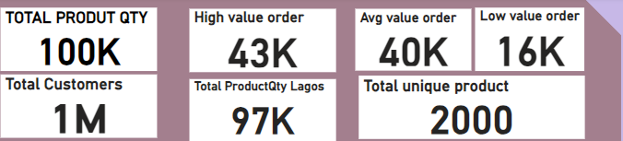

*This section in my visualization highlight the Total product by Quantity, Total Product Quantity sold in Lagos state, This clearly shows Lagos state sold more than Half of the Total Quantity of 2000 unique product as seen above from the period of 2018-2022.*

*We developed a criterion that helped us group quantity sold as high value order, average value order and low value order. This is the criteria* ***(****Greater than 75 High Value Orders, Less than or equal to 75 Average Value Orders, Less than 40 Low Value Orders) Now when you filter which is the next image I would explaining, you will also find out that Lagos has the highest amount of quantity purchased across all criteria.*

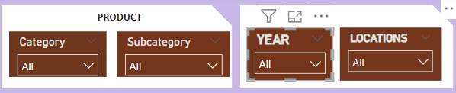

*This section in my visualization will enable you filter Category, Subcategory, Year and Location column to get specific details of whatever outcome you wish to get. For the purpose of this report we would be focusing on Lagos State.*

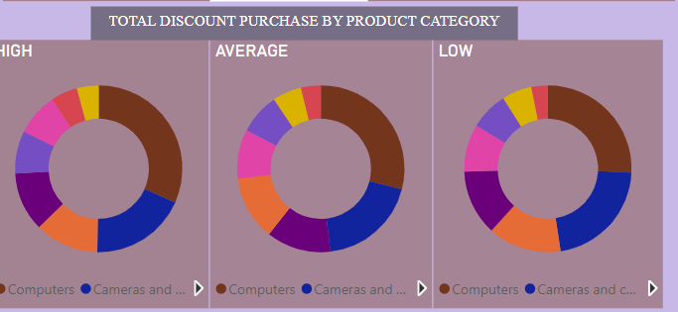

*This section allows us to see what product was sold more during different discount rate, This would help the investment plan giving us an idea of what our customers in Lagos prefers and as we can see they purchase more of computer products which ranges from computer accessories, laptops, desktop, mouse, projector and screen, printer and scanner etc). This explains why we have the sub-category as a filter just incase we want to bring it down to know the exact products (sub-category) purchased more, which I will discuss more in my recommendations.*

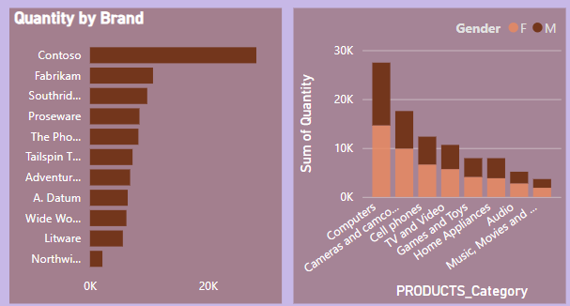

*The first picture from your left shows quantity by brand and we can see contoso brand did better compared to other brands as the range difference is far wide for a competition.*

*The second picture to your right just describes quantity purchase by product category and gender, making it easy to know what product category is a high flyer and those that are outliers.*



*This category enables you to see in numerals how customers quantity purchase was during different product discount levels.*

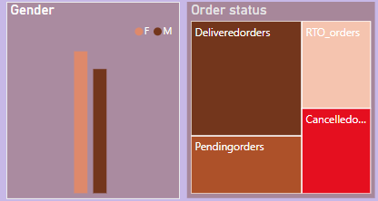

*This category helps us see basically how the gender purchase performed across all filter. The order status shows the total amount of product that were either delivered, pending, RTO_orders or cancelled.*

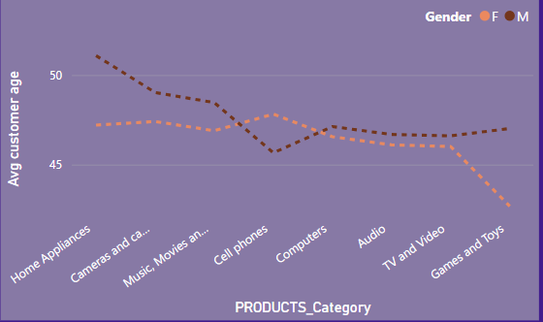

*This Line chart shows the Age range of customers according to their different gender and we can see most people purchasing home appliances are mostly elderly men and we do not have men below (-45) purchasing any products. That is not the case for the females we can see we do not have females below (-50) purchases any product and we also have a dip below 45 for females purchasing games and toys.*

**RECOMMENDATION**

* **The total pending and cancelled order in Lagos from 2018-2022 is 18,427 as against 39,909 delivered order. The management need to look into the causes of pending and cancelled orders because this could lead to customers dissatisfaction thereby leading to a decline in sales.**
* **The highest was purchased occurred when we the company was running an Average discount purchase. This could be due to different psychological reasons when the discount is too high people might think they are trying to sell off old products or the products are on the verge of expiry, when products discount are low customers might go to a different store that offer similar products. So, I would advise we stick to the Average discount were customers would have it somewhat difficult to resist the offer and the store/company would not come off as needy.**
* **In 2021 sales dropped compare to 2019 and 2020 but in 2022 there was a significant increase in sales, looking at the visualization after filtering you would noticed that in 2022 we sold 38k which has been the highest in comparison to previous years, we noticed the diversification across product brand compare to 2019 where we had the contoso brand alone was topping the charts. Therefore, I would recommend the store does more of diversification, just in case a brand goes off the market for a while and it also gives customers a wide a range of products to choose from especially the ladies as we can see from the visualization they are form a higher percentage of our customers**
* **we also noticed that more products were bought more by female from 2018-2022, Therefore, advertisement and promotions should be centered on the female gender not neglecting the male gender of course**
* **From the filter you would notice computer products under product_category was the most purchased product across the years, for desktop customers preferred wide word importers and adventure works, for laptops they preferred adventure works, for monitors they preferred adventure works for printers they preferred prose wears, for projectors they preferred contoso, for audio they preferred wide world importers. This is another reason why diversification should be prioritized, which I strongly recommend.**
* **Looking at the quantity by brand chart and quantity by product_category chart you would notice the high flyers and outliers. Brands (Northwind traders) and products (music, videos and audiobooks) that are outliers for different filter reasons/options should be closely checked to get more information on why customers do not go for them probably have a long lasting history of not lasting, difficult to use, short battery life etc. If issues can be rectify go ahead it would boost sales, if not I would recommend this product/brand has little or no investment. Investment should be prioritized on high flyer brands like contoso and fabrikam.**
* **For the line chart we can see products are been purchased by younger females, this information will help us recommend that investment should be focused on different age range for different product, same as the male gender we see home appliances are purchased more by males above 50 therefore promotion for this particular product should be done in areas where we see this age range of people like offices, markets, churches etc.**
* **Going through the Customer table I created a distinct function to count customers, and I noticed there are low turnover of returning customers. I would recommend a customer survey be carried out, to get their response which can be used to know area of customer’s dissatisfaction to enable improvement.**